Analysing Time to event data

Outline of the day

Concept:
- Definition – survival analysis, censoring, types of censoring,
- Functions of survival time 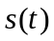, , 
Statistical inference
- Parameter estimation
  - ML approach for censored data
  - Non-parametric approach for estimation
    - Product –limit or Kaplan-Meier approach
    - Aalen-Nelson approach
- Testing of Hypothesis
  - Parametric approach
  - Non-parametric testing of the hypothesis
    - Log-rank test
    - Wilcoxon test
- Regression analysis
  - Cox-proportional
  - Hazard model
Comparison of different methods – adv/ dis
- Practical sessions

Objectives

The objectives of this course are:
- To review simple methods for the analysis of time to event data
- To explain and able to apply different methods for analyzing time to event data.
- To use the R statistical software package to be able analyze the time to event data

SECTION 1
Background for survival analysis

Survival analysis
Survival analysis is a branch of statistics dealing with TIME TO EVENT
For example, in demography – events are deaths or births, in medical science- events are infections time

Objectives of survival analysis
- Estimate probability that an individual surpasses some time-to-event for a group of individuals.
  - Probability of surviving longer than two months until second heart attach for a group of MI patients.
- Compare time-to-event between two or more groups.
  - Treatment vs placebo patients for a randomized controlled trial.
- Assess the relationship of covariates to time-to-event.
  - Does weight, BP, sugar, height influence the survival time for a group of patients?

Types of data
- In survival analysis when the time of event is known, then we have complete information e.g. rat number 4 died on 3rd day. This is called uncensored data
- When the occurrences of the event are not known then we have incomplete information e.g. those rats who escaped. This is called censored data

Two reasons for censoring
- During investigation we have incomplete information due to LOSS TO FOLLOW UP
- When the investigation has come to an end and the experimental units are still alive. This is censoring due to WITHDRAWAL ALIVE

Types/ forms of censoring
- Right censoring – when the experiment is terminated before the event of interest occurs
- Left censoring – occurs when the event of interest occurs before the experiment begins
- Type I censoring – all are equal i.e. 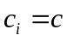(constant) – this is under the control of the investigator
- Type II censoring – observations comes after predetermined number, , of the failures so that becomes a random variable
- Random censoring – each individual is censored at random
- Interval censoring – when a lifetime is only known to fall within an interval
- Informative and non-informative censoring

Functions of T
Let T=time to event i.e. T is a random variable and therefore T has a distribution

- Survival function
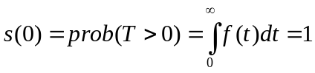
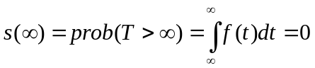
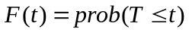
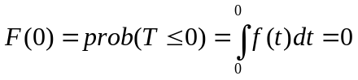
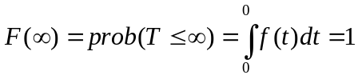

- Probability density function (pdf)
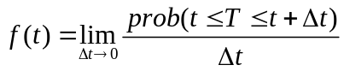

- Hazard function
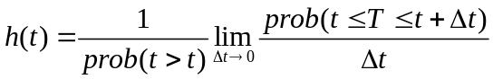
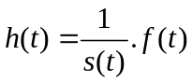
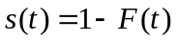
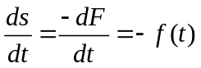
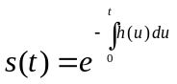

LIFE-TABLE
A life table is a statistical tool for studying a cohort as it diminishes
With time the number or the size of birth cohort diminishes. This is called ATTRITION
It’s used to estimate the survival time but uses interval

STATISITCAL INFERENCE
Has two components
- Estimation
- Testing of hypothesis
There are two methods of approaching them
- Parametric approach
- Non parametric approach
A combination of the 2 approaches gives the regression (i.e. estimation and testing of the hypothesis)

Parametric approach (MLE method) of estimation
Examples of distributions are the exponential and Weibull

The steps followed in MLE
STEP I: take observations of size each with pdf
STEP II: obtain the likelihood denoted by (product of the probability distributions)
Introduce logs – easy to work with 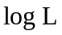
STEP III: Optimization
Differentiate with respect to the parameter of the distribution
MLE for uncensored data (complete)
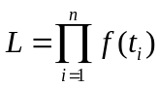

For the censored data the likelihood function is
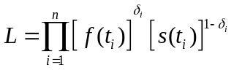

Where 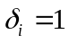 if the 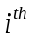life is uncensored and 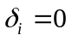 if the life is censored

We can rewrite as
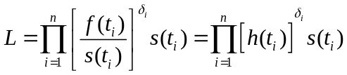

Non parametric approach
- Kaplan-Meier (Product-limit) method

Notations
 - the population/ sample size under investigation
- total number of deaths
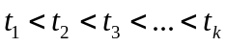 are ordered times of death
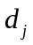 - the number of deaths at time , 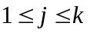
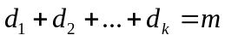
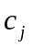 - number censured between time and 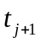; 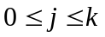
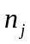 - number of persons at risk just before time

The Kaplan-Meier estimator is given by
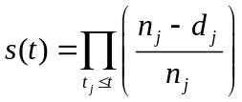
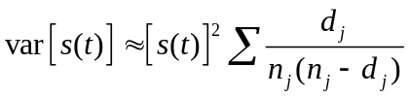
The 95% CI is given by
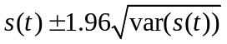

A graph of versus interval 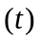 is then plotted

- Aalen-Nelson estimator

Recall: 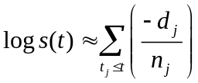 and the relationship between and
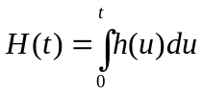 the cumulative hazard function
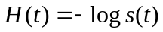
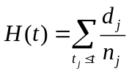
Thereafter
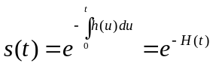

Testing of Hypothesis

In testing of hypothesis we also have 2 approaches – parametric and non-parametric

Normal student t and Fishers F distribution are used for the parametric test

For the non parametric approach  distribution is one of the test statistics used

Log-rank test

We need to test two hypotheses (survival curves)
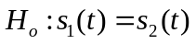
against
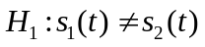

The log-rank test is given by
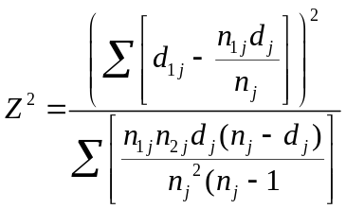which is 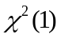
If the calculated is greater than the tabulated at alpha level we then reject the Ho

Other test results include
- Gehans generalized wilcoxon test
- Tarone-Ware test
- Peto-peto—prentice test

With 'rho = 0' this is the log-rank or Mantel-Haenszel test, and with 'rho = 1' it is equivalent to the Peto & Peto modification of the Gehan-Wilcoxon test."

Regression Analysis

Cox proportional hazard model
It’s a technique for investigating the relationship between survival time and independent variables

The exponential distribution is given by
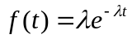, for 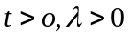
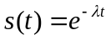
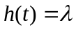
We have need to express to be dependent on some variables which we shall call covariates
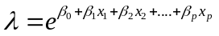

We let and 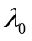 to be functions of
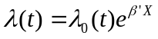

Since is a hazard function, we can replace by

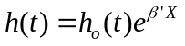which is the cox proportional hazard model

Where
- is the hazard function at time
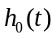 - is the baseline function at time
 - the regression coefficient vector
- is the vector of covariates

The partial likelihood – estimating without 